Run UiPath Program Without Orchestrator or Studio

Step 1:

Copy UiRobot.exe file path from your AppData Directory

Sample path : <<"C:\Users\sramadoss8\AppData\Local\UiPath\app-19.10.4\UiRobot.exe">>

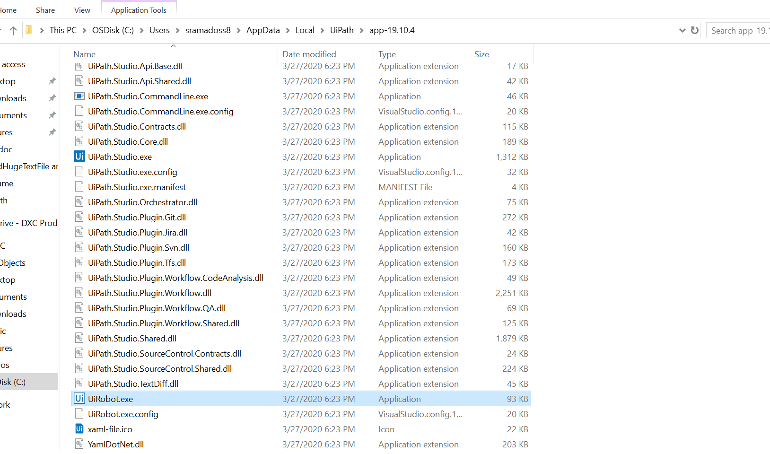

Step 2:

Copy the xaml file path that you want to run

Sample path: <<"C:\Users\sramadoss8\OneDrive - DXC Production\Documents\UiPath\ReadHugeTextFile and API Calls\Main.xaml">>

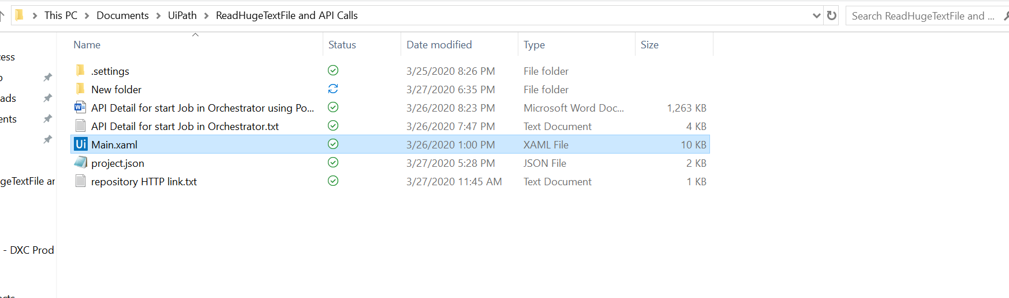

Step 3:

Create file with .bat format and concatenate above two paths in below alignment.

"C:\Users\sramadoss8\AppData\Local\UiPath\app-19.10.4\UiRobot.exe" -file "C:\Users\sramadoss8\OneDrive - DXC Production\Documents\UiPath\ReadHugeTextFile and API Calls\Main.xaml"

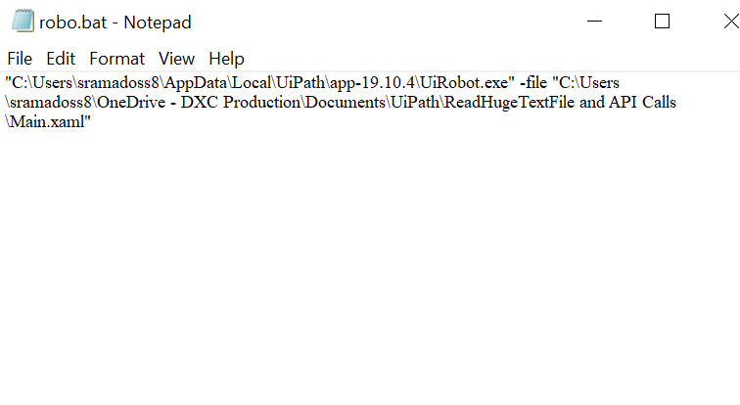

Step 4: Double click on .bat file to run your bot

